COURSE NAME:
Introduction To Software Engineering
COURSE CODE:
IS1103-1
ASSIGNMENT NAME:
SOFTWARE DEVELOPMENT LIFECYCLE(SDLC) ANALYSIS OF LEARNING MANAGEMENT SYSTEM
STUDENT NAME:
AANYA SHETTY
STUDENT USN:
NNM24IS003
SEMESTER AND SECTION:
IV-A
DEPARTMENT:
INFORMATION SCIENCE AND ENGINEERING
INSTITUTION NAME:
NITTE MAHALINGA ADYANTHAYA MEMORIAL INSTITUTE OF TECHNOLOGY
ACADEMIC YEAR:
2025-2026
INSTRUCTOR NAME:
DR.JASON ELROY MARTIS
DATE OF SUBMISSION:
12TH FEBRUARY 2026

Abstract
This project is about a Learning Management System (LMS). An LMS is an online system that helps teachers and students in teaching and learning the curriculum. Teachers can create courses, upload notes, give assignments, and conduct online tests for the students. Students can use the system to study lessons, download notes, submit homework, and check their marks and feedback
This report explains the scope and assumptions of the LMS. It also compares the three popular software development models such as the Waterfall Model, Incremental Model, and Spiral Model. Each model is studied based on requirements, risk handling, time, and cost. The report also discusses requirements validation and the problems that can occur during this phase. Overall, this project shows how a simple and well-planned LMS can improve the learning process and make education more organised.

Github Repo Link :
https://github.com/Aanya1109?tab=repositories

Preface
Education is changing with the help of computers and the internet. Today, teachers and students use online systems to support and smoothen the process of learning. A Learning Management System is one such system that makes teaching and learning easy,interesting, interactive and effective. It helps manage courses, lessons, assignments, and exams in one place without much chaos and confusion.
The aim of this project is to study , analyse and design a simple Learning Management System for a college or university. This report explains the basic working of the LMS, its scope, and the assumptions made while designing it. It also studies different software development models to understand which model is best suited for building the LMS and for what reasons.
This project has helped us understand in a better way on how software systems are planned and developed in real life. It also helped us learn the importance of correct requirements and proper planning for a software development . This report is written in simple language so that it can be easily understood by all readers.

TABLE OF CONTENTS
Abstract 2
Preface 2
Introduction 4
Learning Management System Scope 5
Assumptions 5
Comparative Analysis for SDLC MODELS 5
1. Waterfall Model In Learning Management System (LMS) 5
2. Incremental Model for Learning Management System (LMS) 7
3. Spiral Model for Learning Management System (LMS) 8
Comparison Table…………………………………………………………………………………………………………………9
Conclusion 10
Requirements Engineering Process: 11
1. Functional Requirements of the Learning Management System: 11
2. Non-Functional Requirements of the Learning Management System: 12
Problems in Requirements Validation For LMS 15
Overall Take 16
References 17
DECLARATION OF ACADEMIC INTEGRITY: 18

Introduction
Learning Management System, abbreviated as LMS, is a computer system used for teaching and learning [2]. It operates on the internet. It is a meeting place for teachers and students to learn. They do not have to meet in a class every time. They can access the LMS from anywhere using a computer or mobile phone.
Teachers use the LMS to design courses for students. They upload study notes, videos, images, and other learning materials. Teachers assign homework and assignments through the LMS. They also conduct online tests and exams [4]. After evaluating the answers, teachers assign marks and feedback to students [5]. This helps teachers know how students are learning.
Students access the LMS to read lessons and download learning materials. They can also submit homework online. Students can participate in quizzes and online tests using the LMS [4]. After exams, they can check their marks and feedback. This helps students know their performance and learn better [5].
The LMS also assists in communication [6]. Teachers can send messages and important notifications to students. Students receive notifications about classes, homework, and exams. Due to all these facilities, the LMS makes teaching and learning easy, quick, and organized [3].

Learning Management System Scope
This LMS is intended for a college or university [4], [12]. This is strictly for study work. It assists teachers and students with their day-to-day learning materials. Teachers can create courses for their subjects. They can upload notes, videos, and other learning files for the students. They can also assign homework and assignments using the system [4], [12].
Students can use the LMS to read lessons and download notes. They can also submit homework online without using paper. They can take online tests and quizzes directly within the system. Teachers can view answers and assign marks. All of these are contained in one place, making it easy to locate [4], [2].
This LMS is very simple and easy to use [1]. It does not have any really advanced or additional features. It is designed to address basic teaching and learning requirements. It assists teachers in teaching better and assists students in learning in a simple manner [4].

Assumptions
This system is based on a few very simple assumptions: we assume that teachers and students can use a computer or a mobile phone, that they know how to log in and run basic applications without much help [1], [4]. We also assume that everyone has proper access to the internet, though a little slowness on occasion is tolerated, and the system shouldn't fail completely [4], [12].
We assume that only members of the college or university are permitted to access the LMS; everyone else won't be able to log in [3]. Since time and budget are scarce, we have focused on the most essential features only [1]. We also assume that the pedagogic approach and/or method of setting and conducting examinations will not change radically, so the underlying requirement is that the LMS should be simple and stable [1], [4].

Comparative Analysis for SDLC MODELS

Waterfall Model In Learning Management System (LMS)
Structured approach for creating Learning Management Systems is the Waterfall model. It is based on the principle of finishing one task at a time and moving on to the next task. Here, the current task is completed, and only after completion is the next task taken up [1]. It is best suited for Learning Management Systems for which the school/college already has a clear idea of online classes, online exams, and student records and expects minimal changes from the current system [1], [2].
First, we have Requirements Analysis. In this step, we typically sit down with teachers, students, and other staff members and try to get as many needs as we can [1], [3]. The teachers express how they will be using the system themselves to share notes, assign work, conduct exams, and all that. The students express how they want to be logging in, how they want to watch classes online, how they want to be submitting tasks, and how they want to be viewing grades.
Next up is System Design. This is where the team prepares how the LMS will be like behind the scenes [1]. This includes planning how the login would link up with data stored, or where courses and videos will be housed. There is also planning involved on how exams and scores show up on the screen. This provides a good idea of what the LMS will be like before any coding [1].
Next, we have Implementation. This is the stage where the developers begin coding the LMS. They include login, course, content upload, exam, etc., options. During this time, the ideas are already pre-approved, and new ideas are not introduced. The developers only focus on making the LMS fully functional [1].
After that, the LMS enters Testing. Scenarios are simulated where students log onto the LMS, participate in courses, attend classes, and complete tests, while teachers are able to upload content and grade the tests [1]. Any bugs identified are fixed before the LMS is available to everyone.
Finally, Deployment and Maintenance. The LMS software is deployed to students, teachers, and administrators, and used regularly for teaching and learning [1]. Minor bugs, for example, related to logging in or display will be fixed where it is needed.

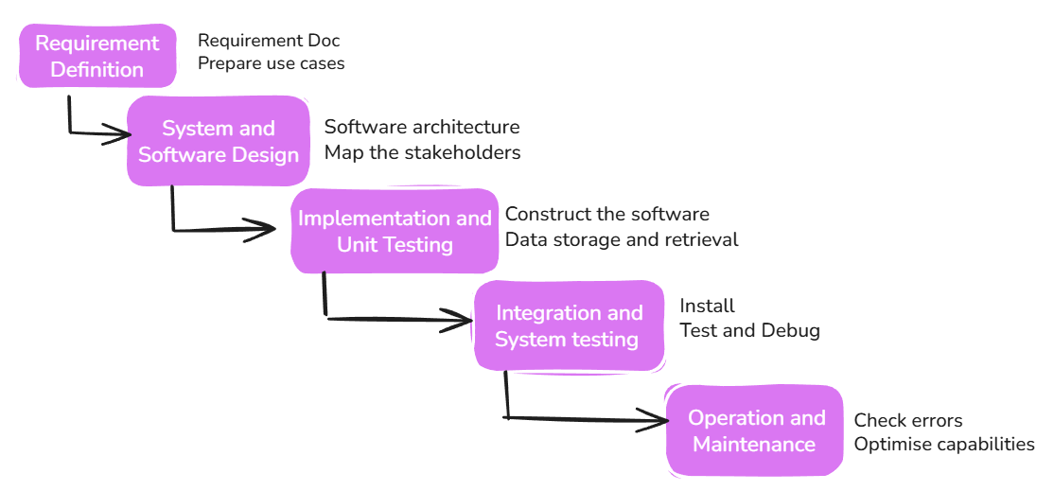

Figure 1: Waterfall Model for LMS

2. Incremental Model for Learning Management System (LMS)
In the Incremental Model, we develop the LMS piece by piece. We don’t develop the entire system at the same time. We begin with a small piece and add more pieces later [1], [4]. Each piece can function independently and can be used even while working on the next piece [1], [4]. This is beneficial for schools because students and teachers can begin using the LMS from an early stage, even if some functionalities are not developed yet.
First, Basic LMS Features. In this stage, students can log in and view courses. Teachers can upload study materials. It is basic but sufficient for students to begin learning.
Second, Assignments & Homework. Teachers can upload assignments, and students can submit homework assignments online. Teachers can evaluate homework and assign marks. This stage follows after the first stage is fully functional [4].
Third, Exams & Results. Students can take online exams, and teachers can assign grades. Students can view their grades. This stage makes the LMS more functional because students can take online exams.
Fourth, Notifications & Messaging. Teachers can send messages or notifications to students. Students receive notifications about new courses, homework, or exams. This stage helps students stay organized and updated.
In the Incremental Model, each stage is developed before moving on to the next stage [1], [4]. This ensures that the LMS remains functional at all times. Once all stages are completed, the LMS is fully developed and ready for use by students, teachers, and admins.
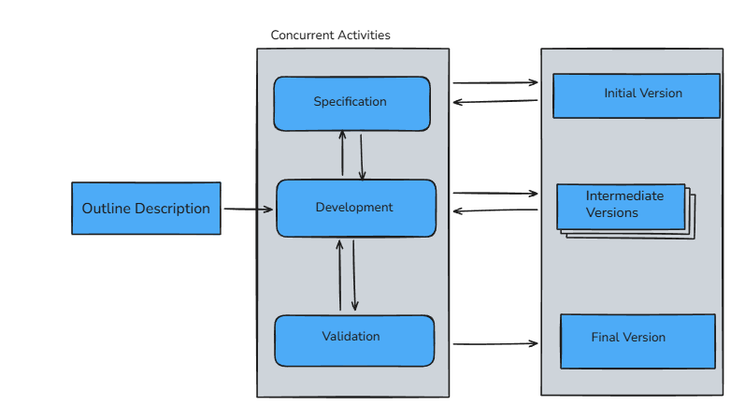
Figure 2: Incremental Model For LMS

3. Spiral Model for Learning Management System (LMS)
The Spiral Model is a series of loops to develop the LMS. Each loop is like a circle. We plan, build, test, and improve [1], [5]. This is totally awesome for the LMS because it allows us to find errors early and make safe additions [5].
First, there is Planning. This is where we determine what we want to work on first. For instance, we could plan student login, course pages, and notes uploads. This is important because it allows all of us to know what we are doing and what we are going to build first [1].
Next, we have Looking for Problems (Risk Analysis). This is where we think about what could go wrong. For instance, maybe the server will crash, information will be lost, or students won’t be able to log in. By thinking ahead, we can avoid making huge mistakes before they happen [5].
Then, there is Building, also known as Development. This is where the programmers build the LMS features such as login, course pages, assignments, exams, and other critical components. They do this based on the plan and build it carefully [1].
The fourth step is Review and Planning Next Loop. This is where we review what we have done and see what we can improve or add next. For instance, maybe we could plan notifications, messages, or new exam features for the next loop. Then, we begin a new circle and go through the same steps again [5].
By repeating these steps in many loops, the LMS is continually improved. New and improved features are added safely, and issues are resolved [5]. Eventually, the LMS is complete and ready for use by students, teachers, and administrators.
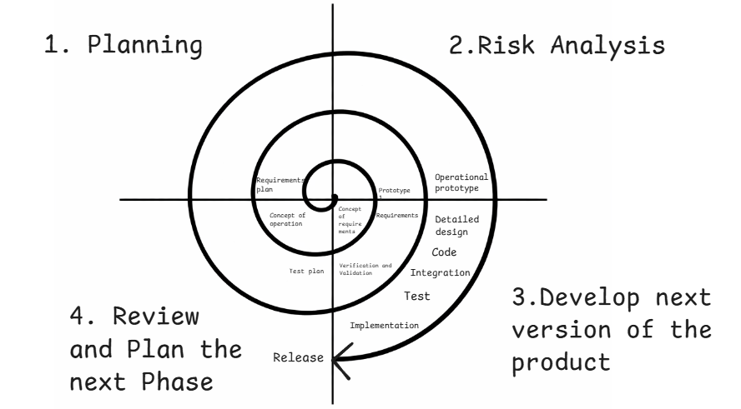
Figure 3: Spiral Model For LMS

Comparison of Software Models for Learning Management System (LMS)

Point | Waterfall Model |  | Spiral Model
  Incremental Model
What it is | Work is done step by step. | Work is done little by little. | Work is done in rounds.
How LMS is made | The full LMS is made at one time | LMS is made in small parts | LMS is made better again and again
Login and Courses | Planned at the start only | Made in the first small part | Planned in every round
Assignment | Added only after full build | Added in later parts | Added step-by-step with checks
Rules and Needs | All rules are fixed at first | Rules can change slowly | Rules are checked many times
Changes | Changes are very hard | Changes are easy | Changes are easy
Risk | Problems are found late | Small problems found early | Big problems found early
User feedback | Students see the LMS at the end | Students use LMS early | Students give feedback often
Time | Takes more time | Takes less time | Takes more time
Cost | Cheap first, costly later | Cost is divided | Very costly
Difficulty | Easy to understand | Medium difficulty | Hard to understand
Best use | When nothing changes | For most schools and colleges | For very big systems

Conclusion
We discussed three software development models: Waterfall, Incremental, and Spiral. These models are all used for developing software, but they differ from each other [1], [5]. None of these models can be applied to all projects. The choice of the model depends on the type of work being done [1]. For an LMS, you would like to have something that can evolve and improve over time.
The Waterfall Model is step-by-step. One step has to be completed before the next step begins [1]. It is easy to comprehend and easy to implement. It is best suited for small projects where nothing needs to be changed. However, for an LMS, this is not the best option because changes are frequent, and in Waterfall, it is difficult to make changes once a step is completed [1].
The Incremental Model is piece by piece. It develops software in small pieces [1]. You begin with basic functionality and add more later. Users can begin using the software early, and they can provide feedback, which helps to improve the software. This is the best option for an LMS because changes are easy, and it is done in a phased manner [1].
The Spiral Model is round by round. Each round includes planning and testing [5]. It catches and fixes problems early. It is best suited for large systems like an LMS because it helps to reduce risks and increase quality [5]. However, it is complex, more costly, and requires expertise [5].
In conclusion, Waterfall is simple but rigid [1]. Incremental is more suited to an LMS [1]. Spiral is best suited to a large LMS [5]. Therefore, for an LMS, the Incremental or Spiral model is better than the Waterfall.

Requirements Engineering Process:

Functional Requirements of the Learning Management System:
• Student and teacher login:
The system should allow students and teachers to log in using a username and password. This ensures that the system knows who is using it and that passwords are secure. Only the person who should be using it can get into their things [3], [6].
• Teachers can create courses:
Teachers should be able to create new courses. A course might be something like Math or Science. Teachers can name it and enter details so students know what they are learning [6].
• Teachers can upload notes and study materials:
Teachers should be able to upload notes, books, and videos. These help students study at home. Teachers can enter new files at any time, so students don’t have to ask again [4], [6].
• Students can view and download study materials:
Students should be able to view the notes easily and download them to study later. This is helpful when there is no internet, making study quick and easy [4], [6].
• Teachers can give assignments:
The system should enable teachers to give homework online. They can indicate what is to be done and by when, reducing the use of paper. Students will view all assignments at once [4], [6].
• Students can upload homework online:
Students should be able to upload their homework online, without having to come to class. This is especially helpful when they are at home, and teachers can easily access the homework [4], [6].
• Teachers can give online tests:
Teachers should be able to create tests online using the system, with questions and time limits. This will help assess learning and reduce the use of paper [4], [6].

• Students can take online tests:
Students should be able to take tests online, answering questions directly on the screen. The system will save their responses for easy access. Taking tests will be easy and safe [4], [6].

Non-Functional Requirements of the Learning Management System:
• Super easy to use:
The system should be really simple. Students and teachers should get it quickly. Buttons and options need to be clear. Even newbies shouldn’t be puzzled [1], [3].
• Handles lots of users without a hitch:
It should run smoothly even when many students are using it at once. It shouldn’t crash or slow down. Everyone should be able to study at the same time. This is huge during exams [1], [5].
• Keeps data safe:
All data should stay secure. Student grades and teacher files should be private. Passwords need protection. Safety matters a lot [1], [3].
• Loads fast:
Pages should open quickly. Students shouldn’t wait around. Fast loading saves time and makes learning nicer [1].
• Always up and running:
The system should be available all the time. Students might study in the morning or late at night. Teachers might upload work anytime. It shouldn’t go down often [1], [5].
• Works on phone and computer:
It should run on mobile phones and laptops/desktops. Some students use phones, others use laptops. Everyone should be able to use it easily [4], [6].
• Doesn’t lose data on slow internet:
If the connection is slow, the system should still save work. Assignments and tests shouldn’t get lost. That keeps students feeling secure [1], [3].
• Easy to update and maintain:
The system should be simple to fix and update. New features can be added later. Problems should be easy to solve. This keeps things running well [1].

Requirements Validation In Learning Management System (LMS)
Requirements validation is a process of re-verifying the details of the LMS to ensure they are spot on. It also helps us validate that the LMS we are developing is exactly what teachers, students, and admins need. This is done before we fully develop the system. It is extremely crucial, as errors here can lead to more time and money being spent on correcting them later [1], [3].
If an error creeps in after the LMS has been developed or is already in use, it is much more difficult to correct it. When there are changes in the requirements, changes in the design and code are also required, and you have to re-test the entire system. This is why it is more expensive to correct issues related to requirements than it is to correct a small bug in the code [1], [3].
- Validity Check in LMS:
This is a check to ensure that the LMS is doing the right thing. Sometimes teachers feel they require one functionality, but then they change their minds and want something else. For instance, a teacher may begin with uploading notes only, but then later want video classes as well. Everyone—students, teachers, and admins—wants something different, so we re-verify the requirements of the LMS to ensure that they actually meet what the users want [1], [3].
- Consistency Check in LMS:
In this step, we ensure that there are no conflicts in the requirements. A requirement should not conflict with another requirement. For example, one requirement should not state that students can view their marks at any time while another requirement states that the marks are hidden. All requirements in the LMS should be consistent [3].
- Completeness Check in LMS:
In this step, we check for completeness. There should be nothing left out. The LMS doc should include login, courses, homework, exams, marks, and reports. If any of the major functionalities are left out, the LMS will not function properly. Therefore, all the necessary functionalities must be clearly stated [1], [3].
- Realism Check in LMS:
In this step, we check if the concepts are practical. Some concepts are very appealing but difficult to implement with the available technology. Budget and time are also factors. If the college has budget and time constraints, large functionalities may not be feasible. Therefore, the requirements should be realistic [1].

- Verifiability Check in LMS:
This is roughly saying that we should be able to test all the features of LMS. For example, can we log in as a student, take an exam, and see the results? If we can’t test a feature, it is likely that the feature is not explained clearly. This prevents fights between users and developers later on [3].
- Requirements Change in LMS:
As time passes, people understand LMS better. Initially, they may not know what they want. Later, after some discussion or seeing examples, they change their minds. So, requirements for LMS change with time. This is common for most systems [1].
- Requirements Validation Techniques for LMS:
There are a few ways to validate requirements of LMS. One of them is review meetings. In these, teachers, students, and developers read the requirements and point out errors. They discuss and correct errors together [1], [3].
Another technique is prototyping. You show a small prototype of LMS or a simple demonstration to the users. They use it and tell you what they like or dislike about it. This helps them understand better and explain what they need better [1].
Another technique is writing test cases. Tests are written for LMS features before development begins. If a test is difficult to write, it is likely that the requirement is not clear [3].

Problems in Requirements Validation For LMS
The first problem is that people usually don’t know what they want right away [1].This is especially true for an LMS, as people don’t really understand it until they try it out [2].
There are also problems with communication. Users communicate in simple terms, but the developers may have different ideas about what they mean [3]. This means that the LMS has features that the users didn’t want or need.
There may also be conflicts in what the users mean [1]. One teacher may want exams to be done in one way, and another teacher may want them done in another way. It becomes difficult to write down one requirement when everyone has a different idea.
There is also a time constraint [4]. Teachers and students have classes, exams, and work. They may not take the time to read the requirements carefully, and small errors get put into the document.
Then there is the problem of changing one’s mind [2]. After seeing the screens of the LMS or using it, people may ask for new features.
Some users may agree to requirements without fully understanding them [3]. Later, they complain that the LMS is not working as they thought it would, and there is confusion and conflict.Because of all these factors, it is very difficult to catch all the errors during the validation process [1]. Some errors will always be found later. This is just the nature of LMS development.
In the Waterfall Model, the validation of requirements is done at the beginning [5]. All the needs of the LMS are gathered and validated before the actual development begins. It is difficult to change the LMS once it is developed, so the Waterfall Model uses extremely strong and thorough validation, which is difficult in LMS development [5].
In the Incremental Model, we test requirements many times [6]. The LMS is developed in small pieces. After every piece, users test it and tell us what they think. This is how we can find errors in requirements early. If something is wrong or missing, we correct it in the next piece. This way, we reduce problems caused by unclear or changing requirements. That’s why it’s good for LMS [6].
In the Spiral Model, we test requirements again and again in every cycle [7]. Every cycle includes planning, checking, and correcting. We identify risks such as exam safety, data security, and system capacity early [7]. If users didn’t understand something, we explain it in the next cycle. This model is very effective in dealing with requirement problems but is more expensive and takes longer [7].
Testing requirements in LMS is difficult because user requirements may change [1]. The Waterfall Model is not good at this because changes are minimal [5]. The Incremental Model is better at this because it allows improvements in stages [6]. The Spiral Model is best at this because it checks requirements and risks many times [7]. Therefore, the Incremental and Spiral Models are more suitable for LMS.

Overall Take
Learning Management System is a super helpful tool for learning and teaching [1]. It helps teachers and students complete their tasks easily. Teachers can upload lessons, assign homework, and conduct exams. Students can study, submit homework, and check their results. Everything related to studies is organized in one place, making it easy to handle [2].
To develop an effective LMS, it is important to choose the right software model [3]. Waterfall Model is easy to understand but difficult to modify later [4]. Incremental Model is flexible and allows modifications to be made increment by increment [5]. Spiral Model emphasizes safety and risk management [6]. In most colleges, the Incremental Model is the most appropriate choice as it saves time, reduces problems, and allows modifications [5].
Requirements validation is another critical aspect [3]. Validating requirements can help avoid many problems later on [3]. Although changes can occur, effective validation can reduce errors. In conclusion, a carefully planned LMS can help enhance learning and make education better and more organized [1].

References
[1] I. Sommerville, Software Engineering, 10th ed. Boston, MA, USA: Pearson, 2016.
[2] R. S. Pressman and B. R. Maxim, Software Engineering: A Practitioner’s Approach, 8th ed. New York, NY, USA: McGraw-Hill Education, 2014.
[3] IEEE, IEEE Recommended Practice for Software Requirements Specifications, IEEE Std 830-1998. New York, NY, USA: IEEE, 1998.
[4] W. W. Royce, “Managing the development of large software systems,” in Proc. IEEE WESCON, 1970, pp. 1–9.
[5] B. W. Boehm, “A spiral model of software development and enhancement,” Computer, vol. 21, no. 5, pp. 61–72, May 1988.
[6] C. Larman and V. R. Basili, “Iterative and incremental development: A brief history,” Computer, vol. 36, no. 6, pp. 47–56, Jun. 2003.
[7] R. K. Ellis, Field Guide to Learning Management Systems. Alexandria, VA, USA: ASTD Learning Circuits, 2009.
[8] N. Dabbagh and B. Bannan-Ritland, Online Learning: Concepts, Strategies, and Application. Upper Saddle River, NJ, USA: Pearson, 2005.
[9] H. Coates, R. James, and G. Baldwin, “A critical examination of the effects of learning management systems on university teaching and learning,” Tertiary Education and Management, vol. 11, no. 1, pp. 19–36, 2005.
[10] W. R. Watson and S. L. Watson, “An argument for clarity: What are learning management systems, what are they not, and what should they become?” TechTrends, vol. 51, no. 2, pp. 28–34, 2007.
[11] K. A. Al-Busaidi and H. Al-Shihi, “Key factors to instructors’ satisfaction of learning management systems in blended learning,” Journal of Computing in Higher Education, vol. 24, no. 1, pp. 18–39, 2012.
[12] GeeksforGeeks, “Software Engineering Models,” [Online]. Available: https://www.geeksforgeeks.org/software-engineering-models/. [Accessed: Feb 10,2026].

DECLARATION OF ACADEMIC INTEGRITY:
I hereby declare that this assignment is entirely my own work and has not been plagiarised from any source. All references and resources used have been duly acknowledged. I understand that any ambiguity may result in the forfeiture of marks.


Student Signature: Submission Date: 12th February 2026

